**HTTP-GET and POST Methods Screenshots**

GET METHOD:

Request:

<https://reqres.in/api/users?page=2>

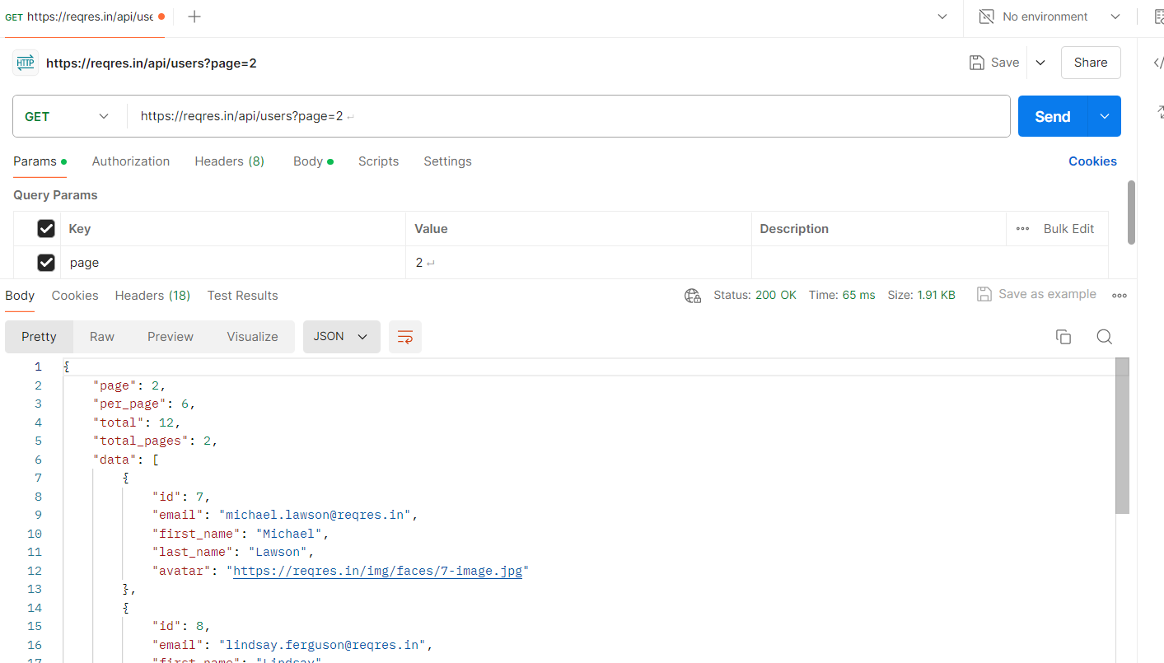

Request

<https://reqres.in/api/users?page=1>

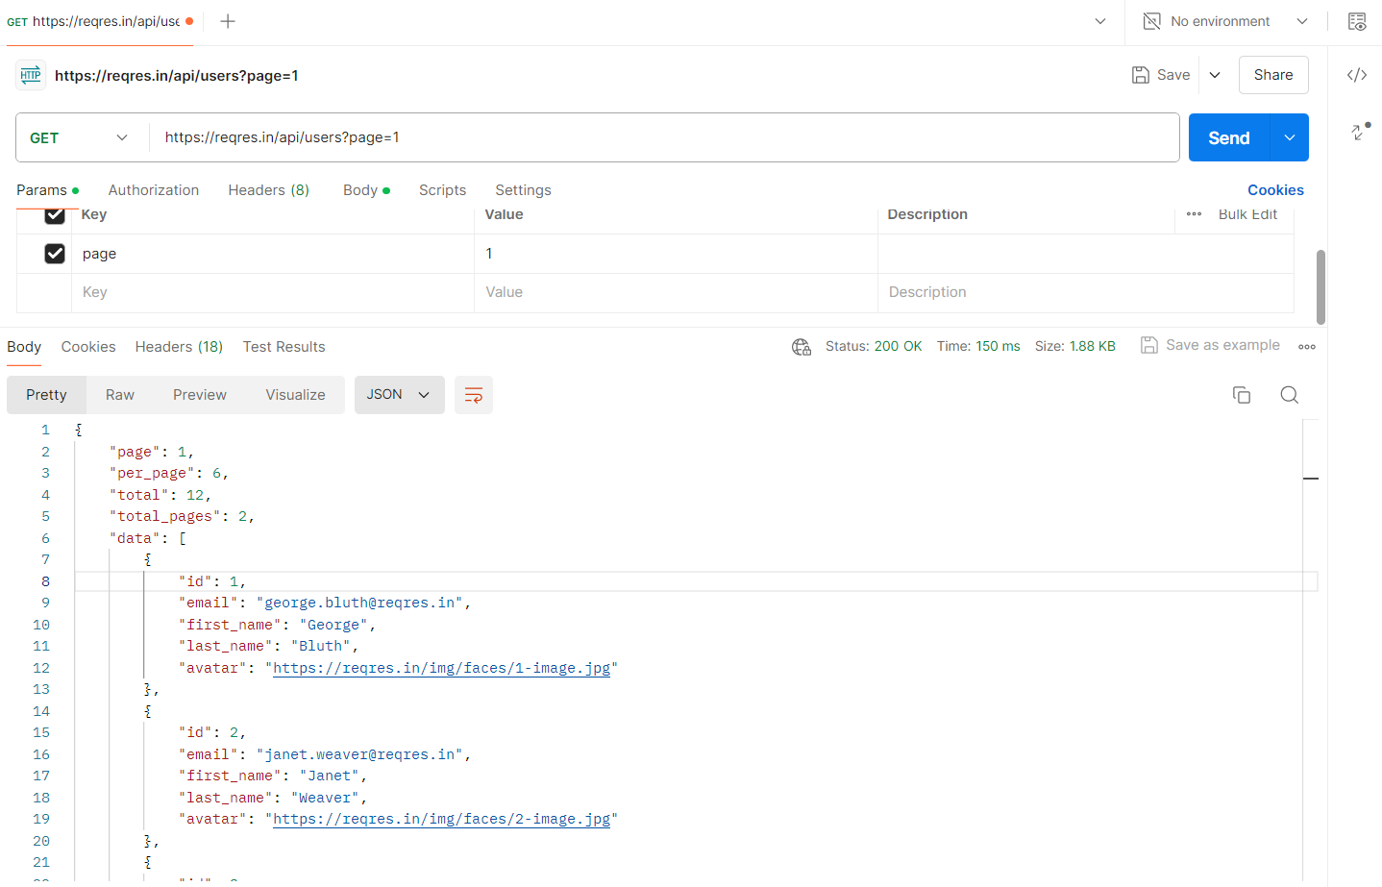

Request:

<https://reqres.in/api/user/6>

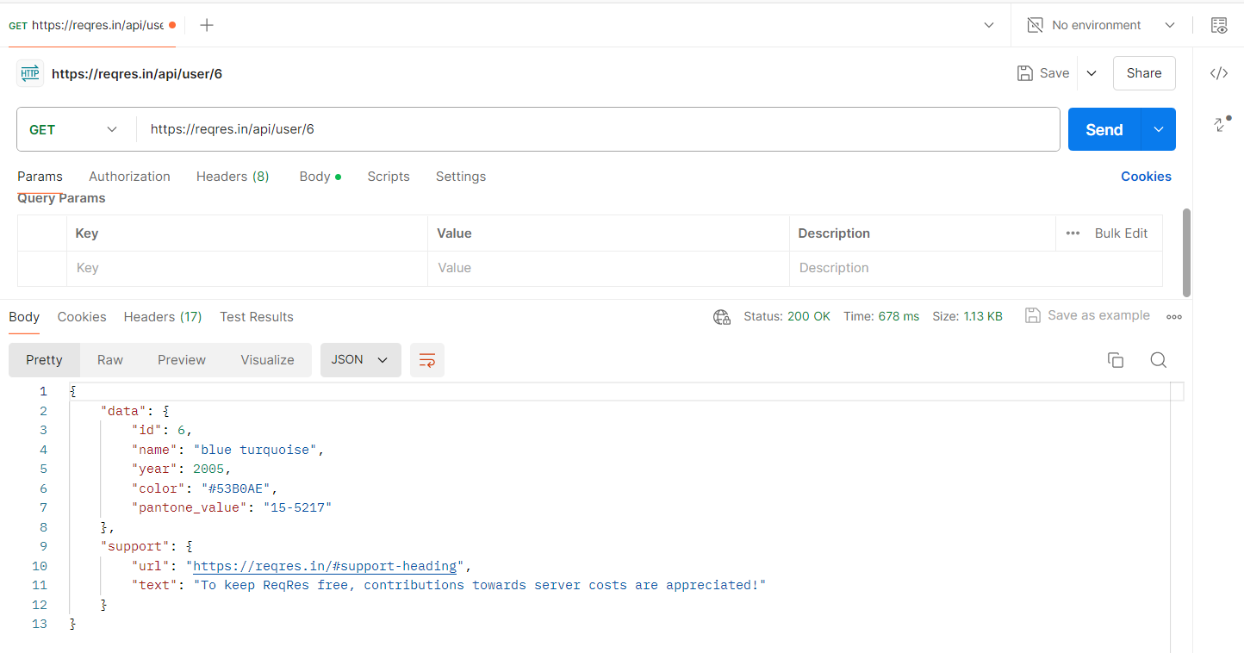

Post Method:

Request:

<https://reqres.in/api/user>

